Sai Sushank Manthri Pramod

Advitha Bawgi

**IFT 530 : Final Project**

Instructor: Ashish Gulati

Due Date : 4/24/24

Tables Creation:

Table 1: Users

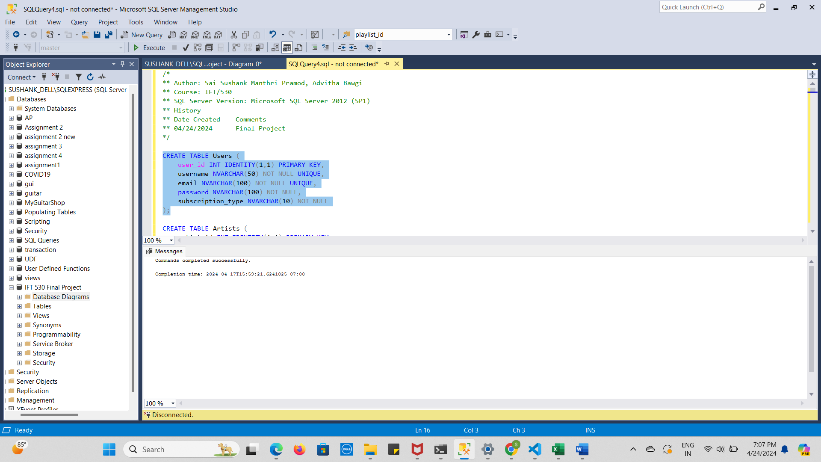

Table 2: Artists

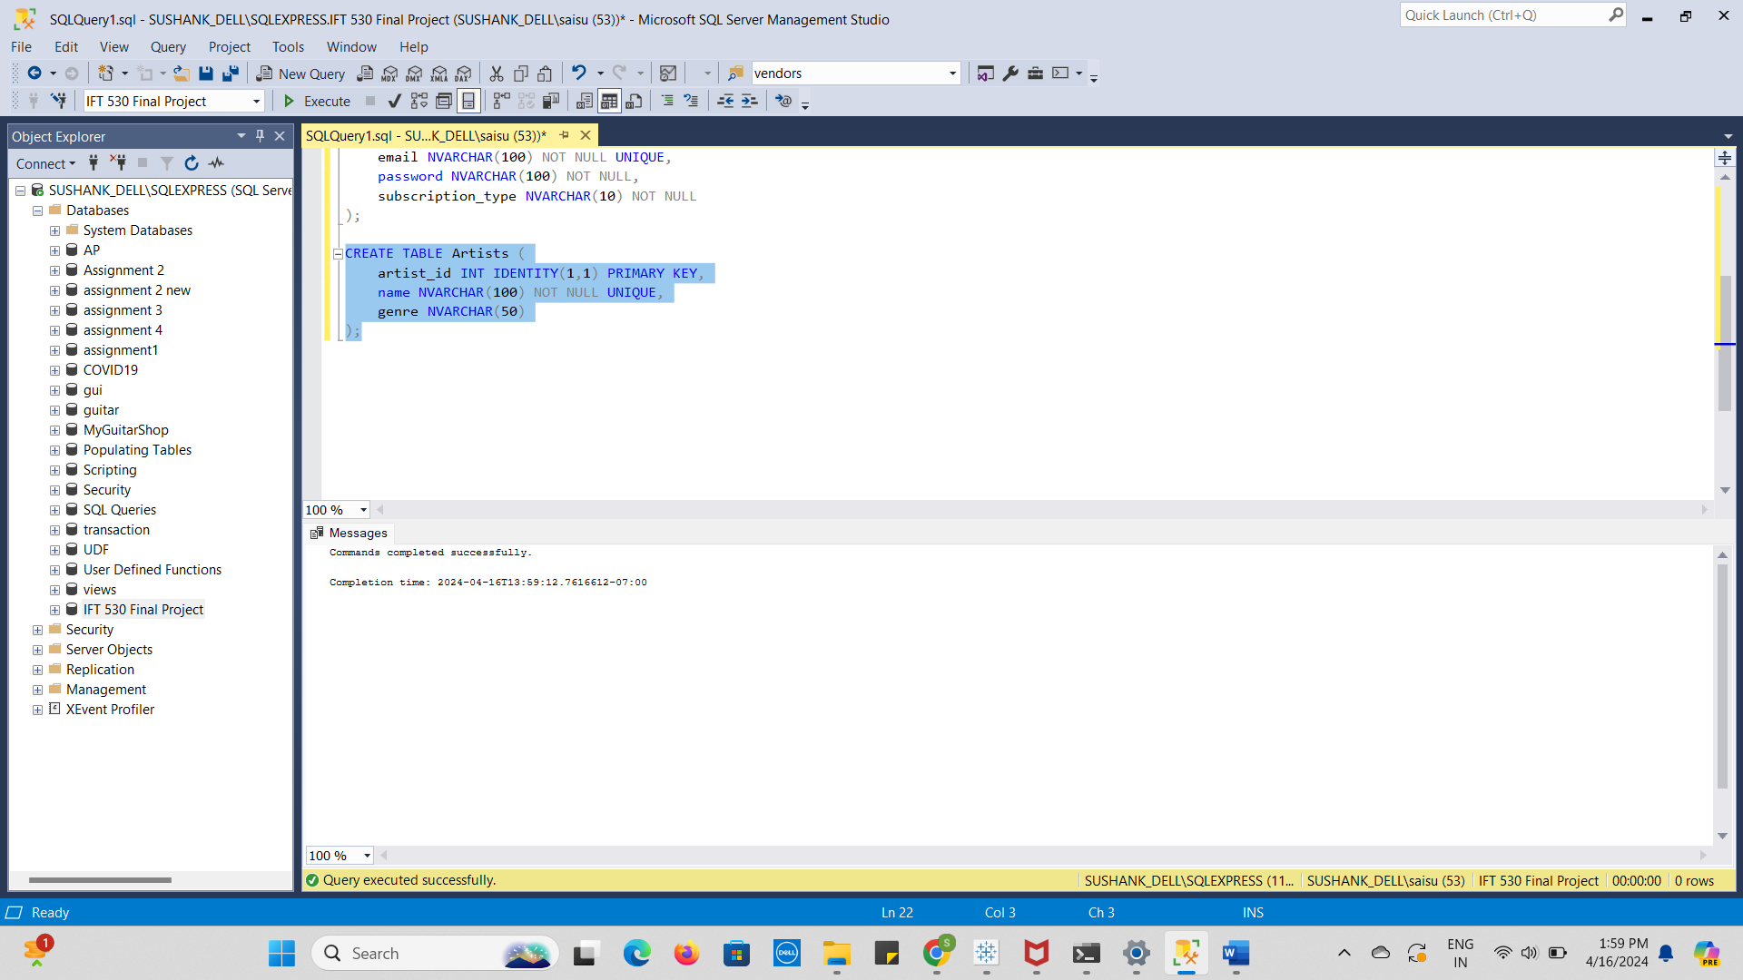

Table 3: Songs

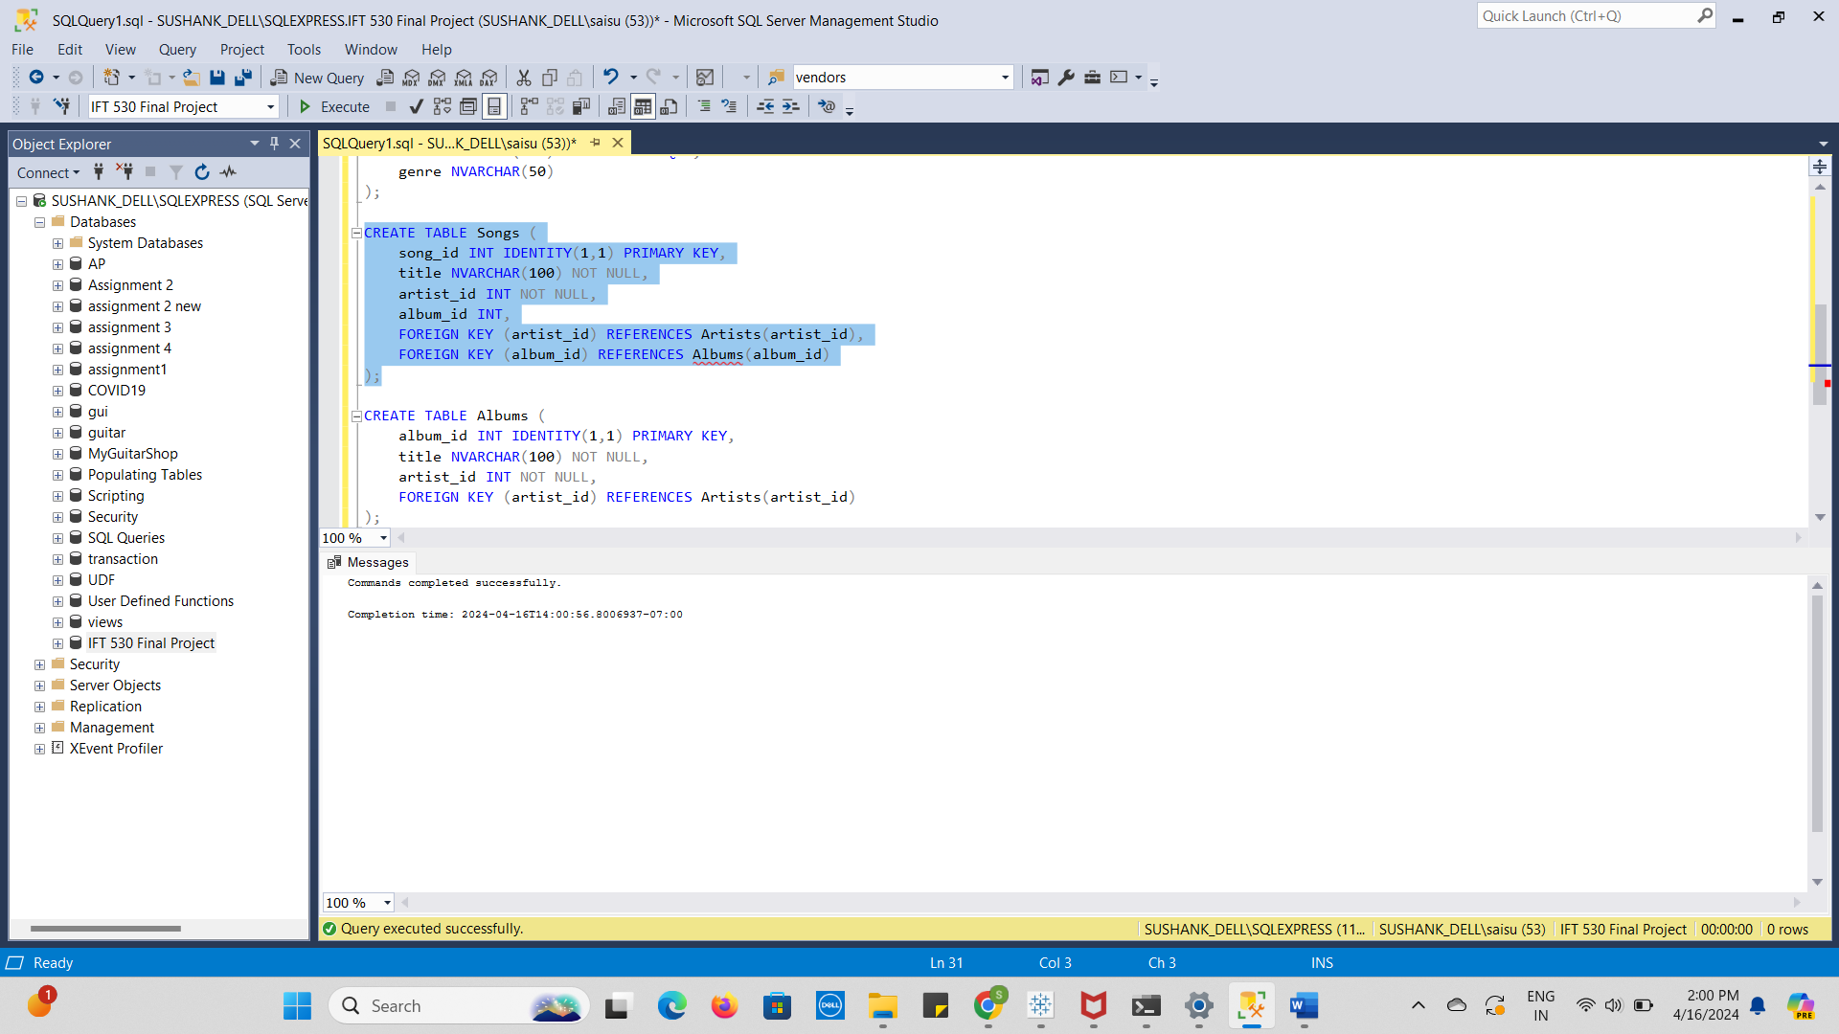

Table 4: Albums

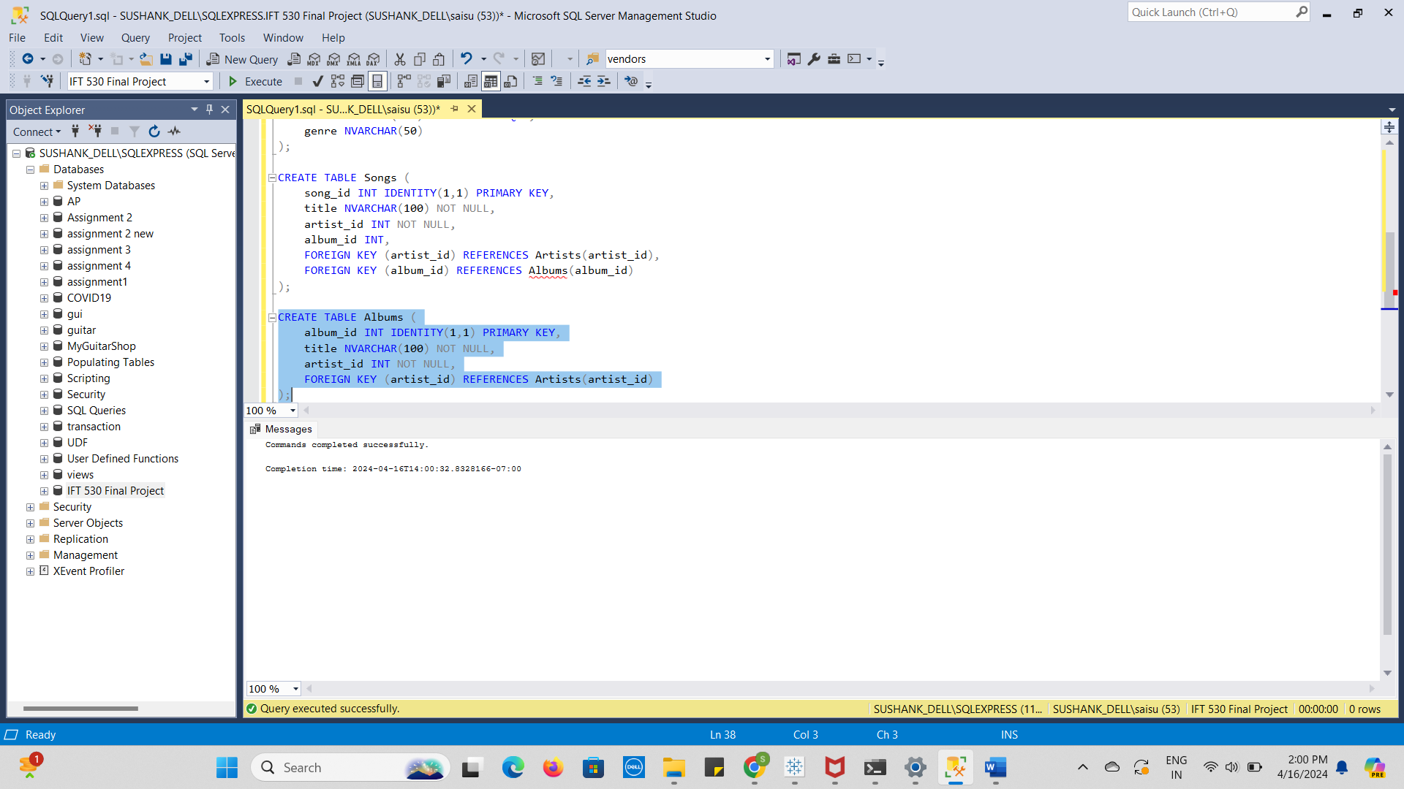

Table 5: Playlists

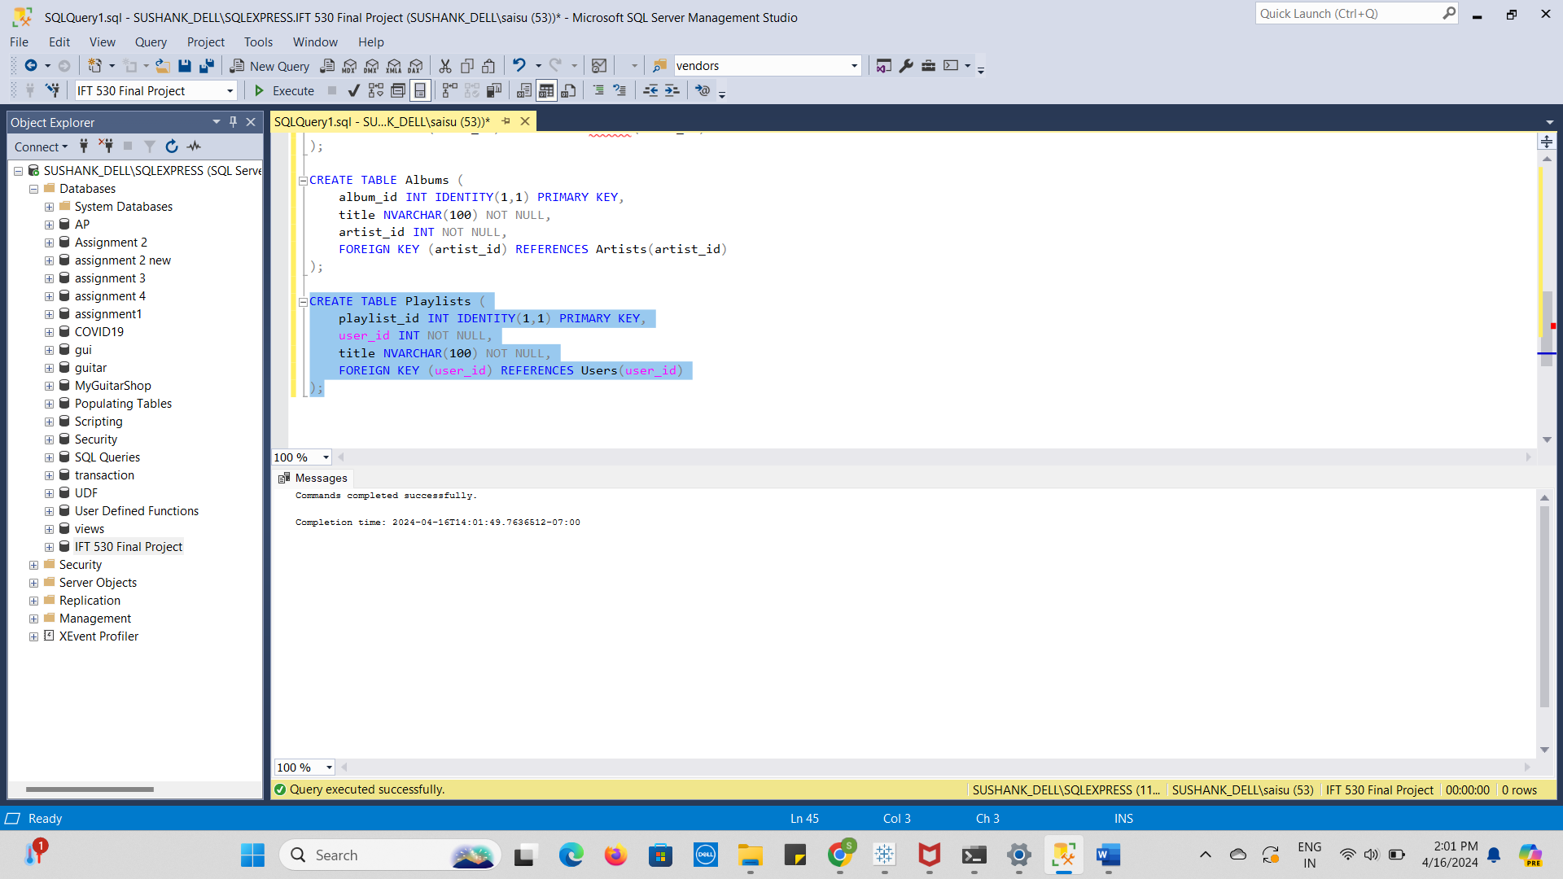

Table 6: listening Habits

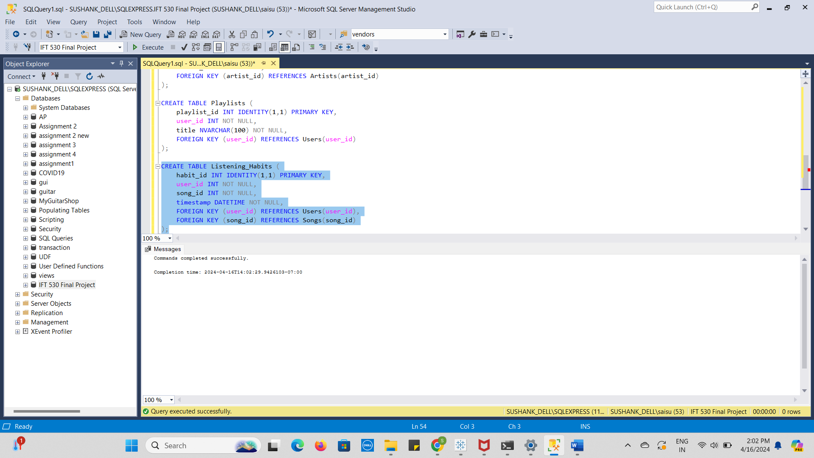

Table 7: Subscriptions

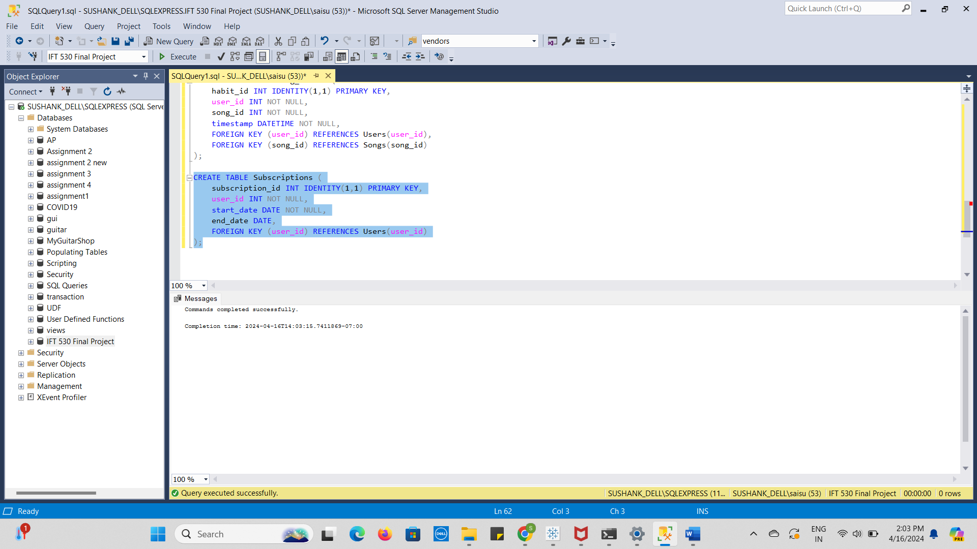

Table 8: Payments

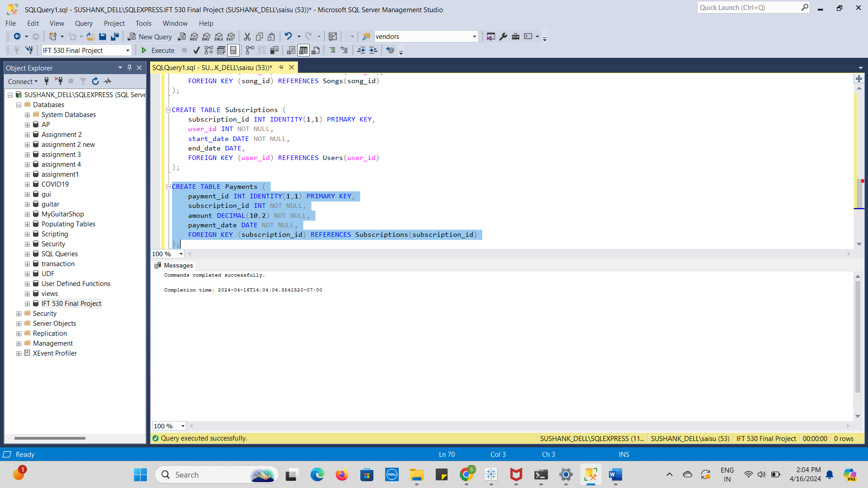

ERD Diagram:



Populating Tables:

Table 1: Users

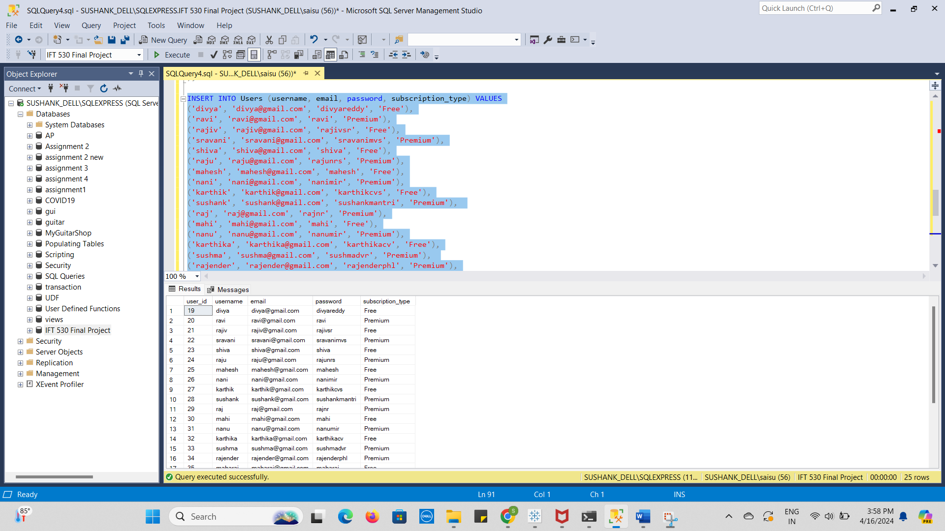

Table 2: Artists

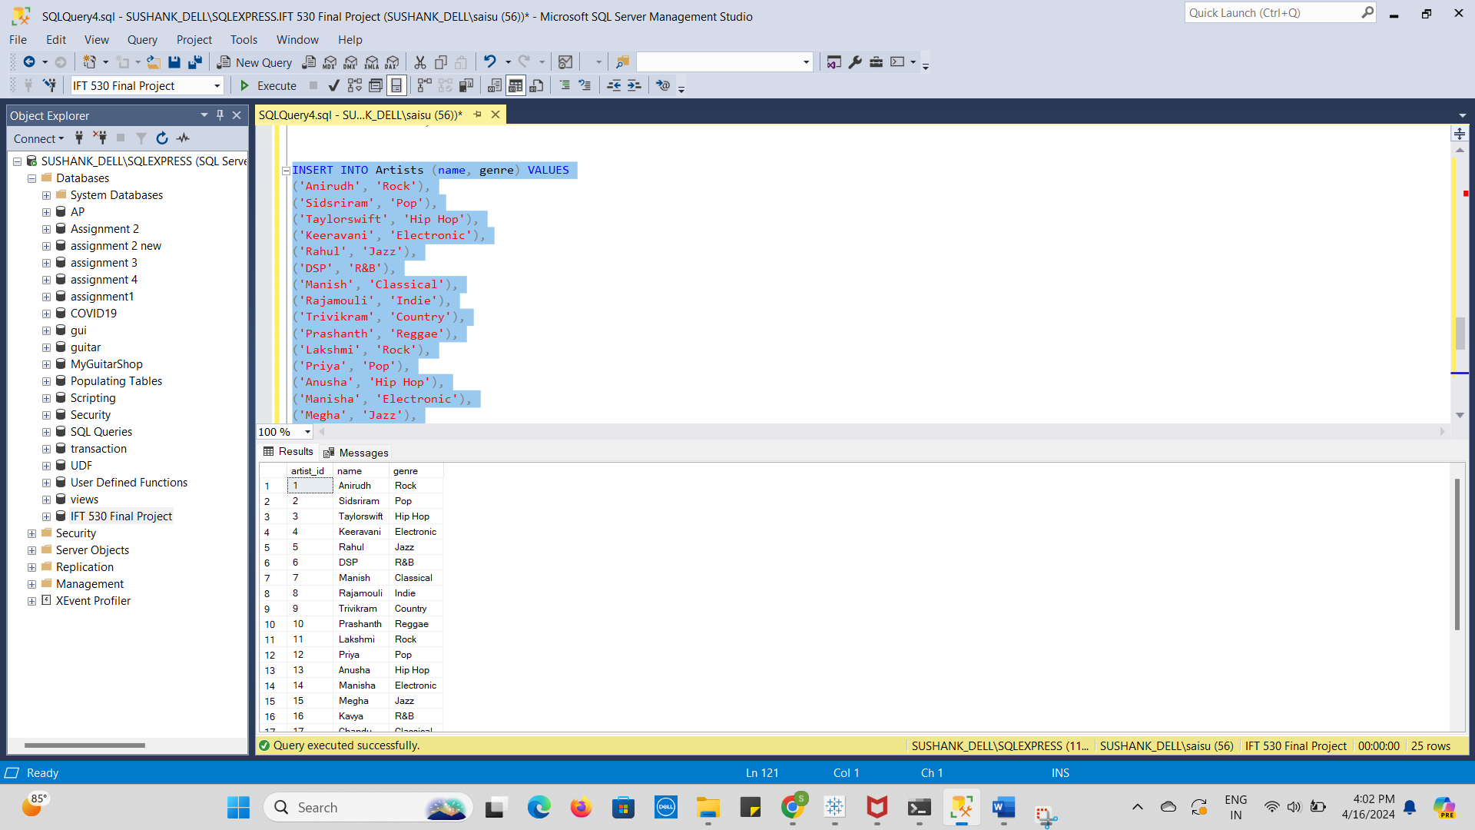

Table 3: Songs

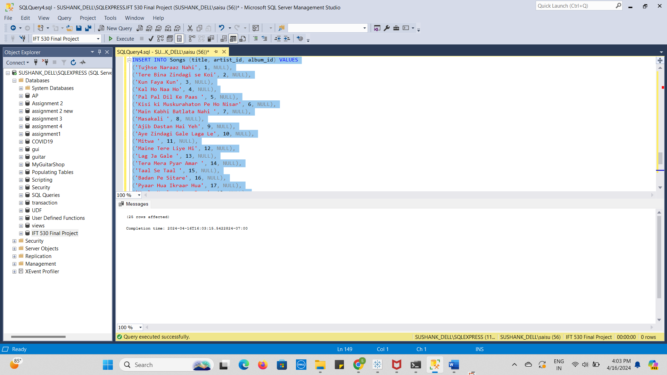

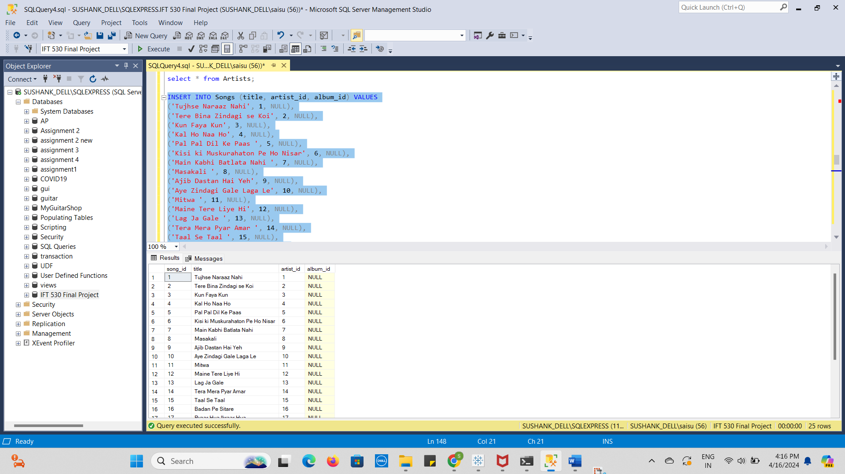

Table 4: Albums

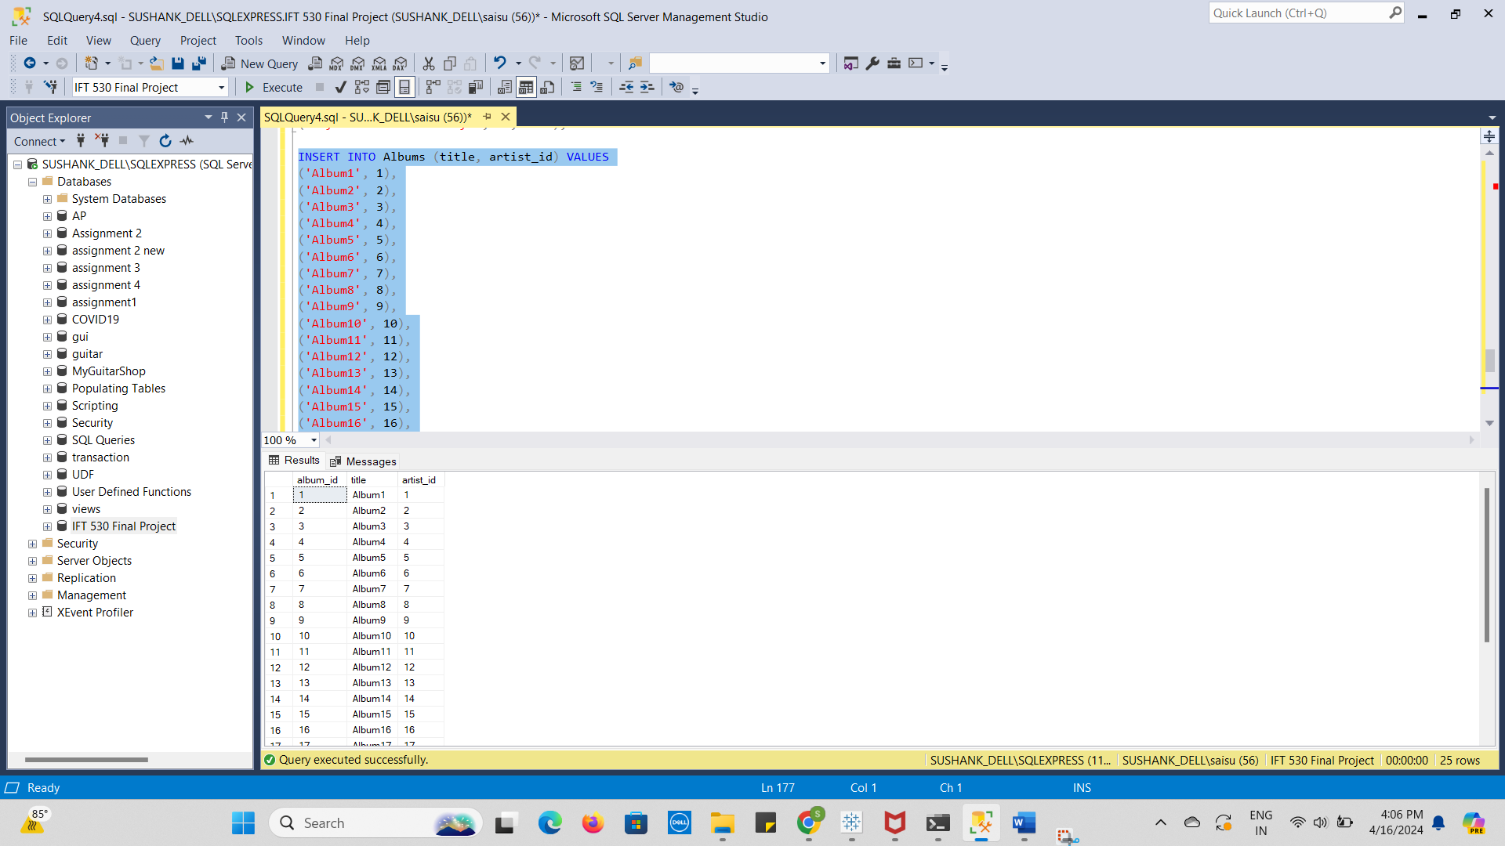

Table 5: Playlists

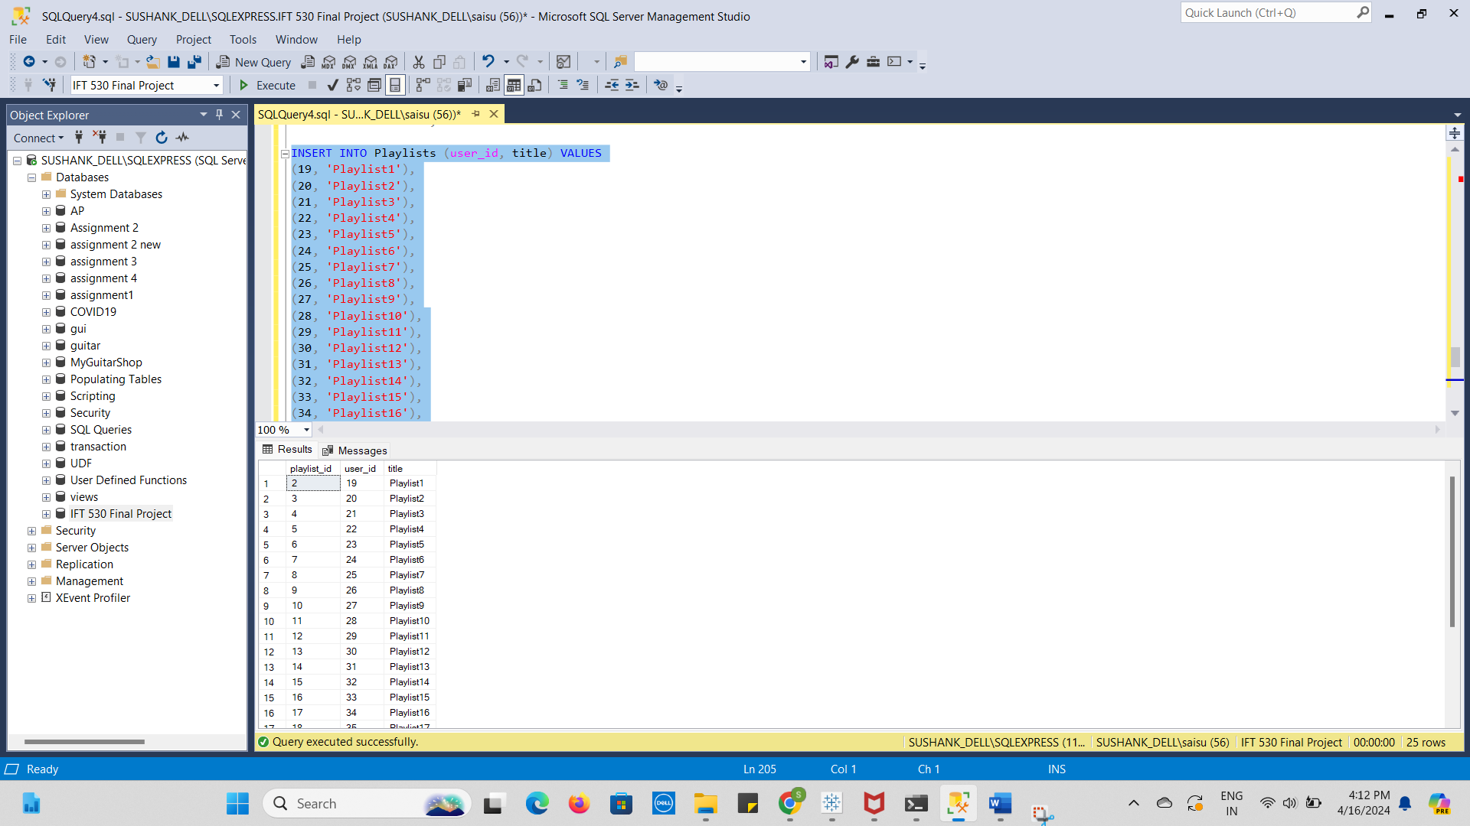

Table 6: Listening_Habits

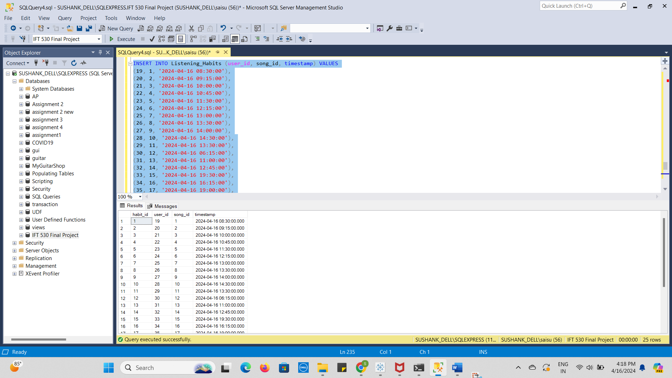

Table 7: Subscriptions

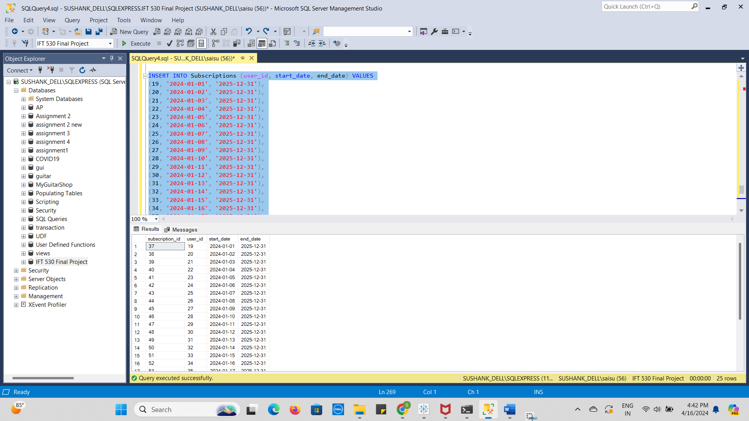

Table 8: Payments

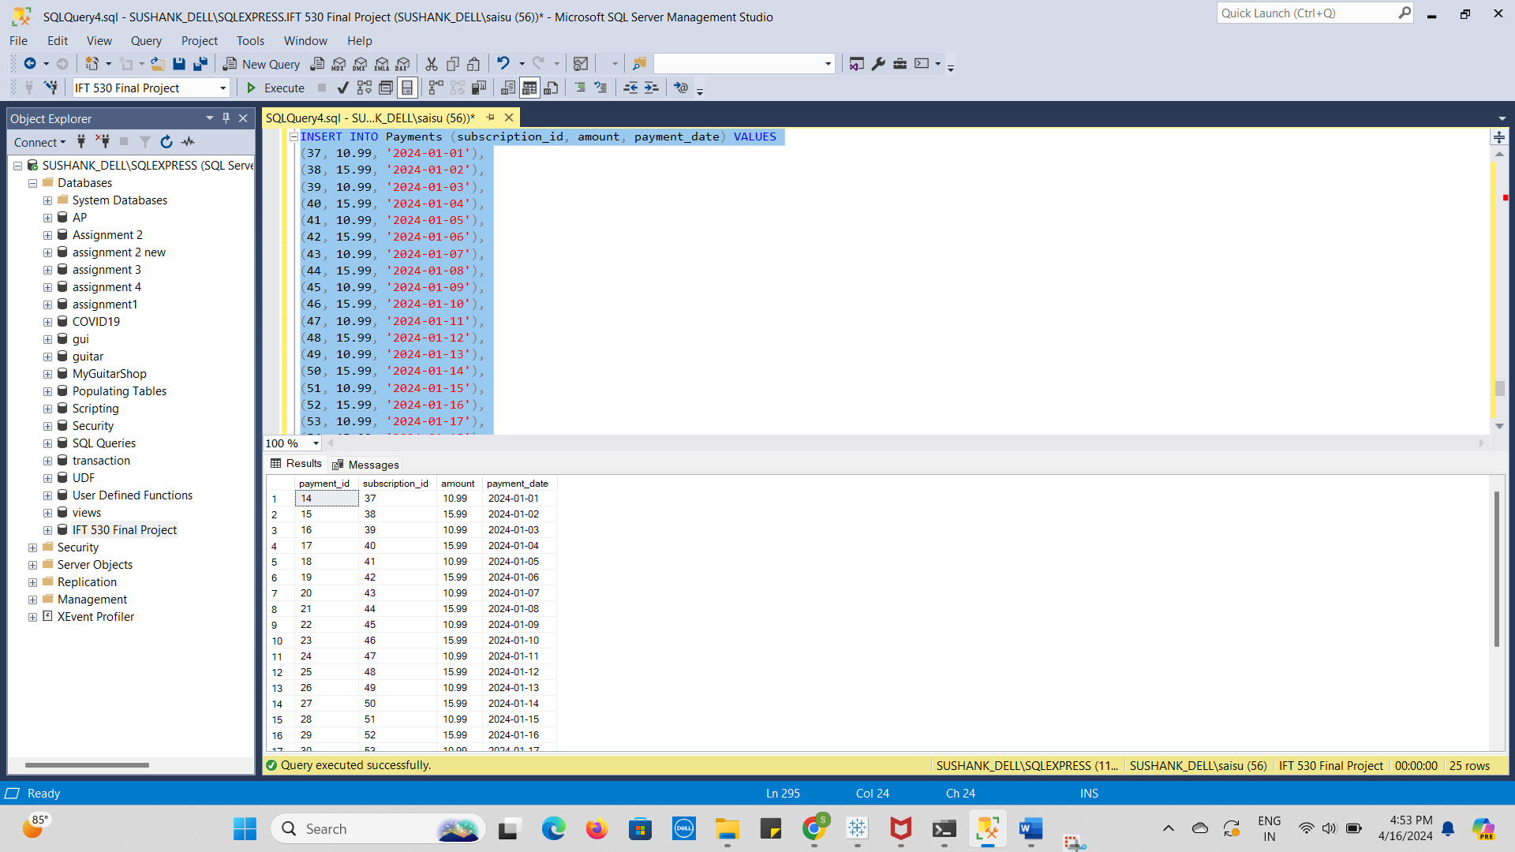

Views:

Query1

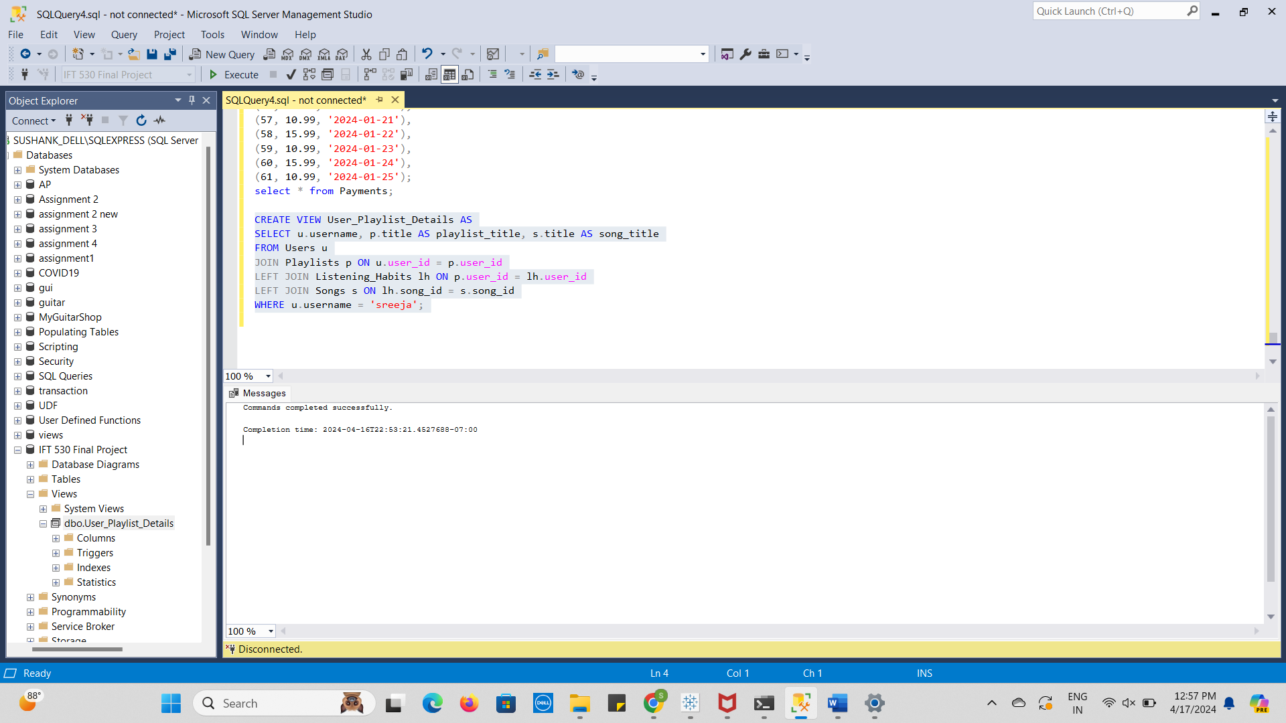

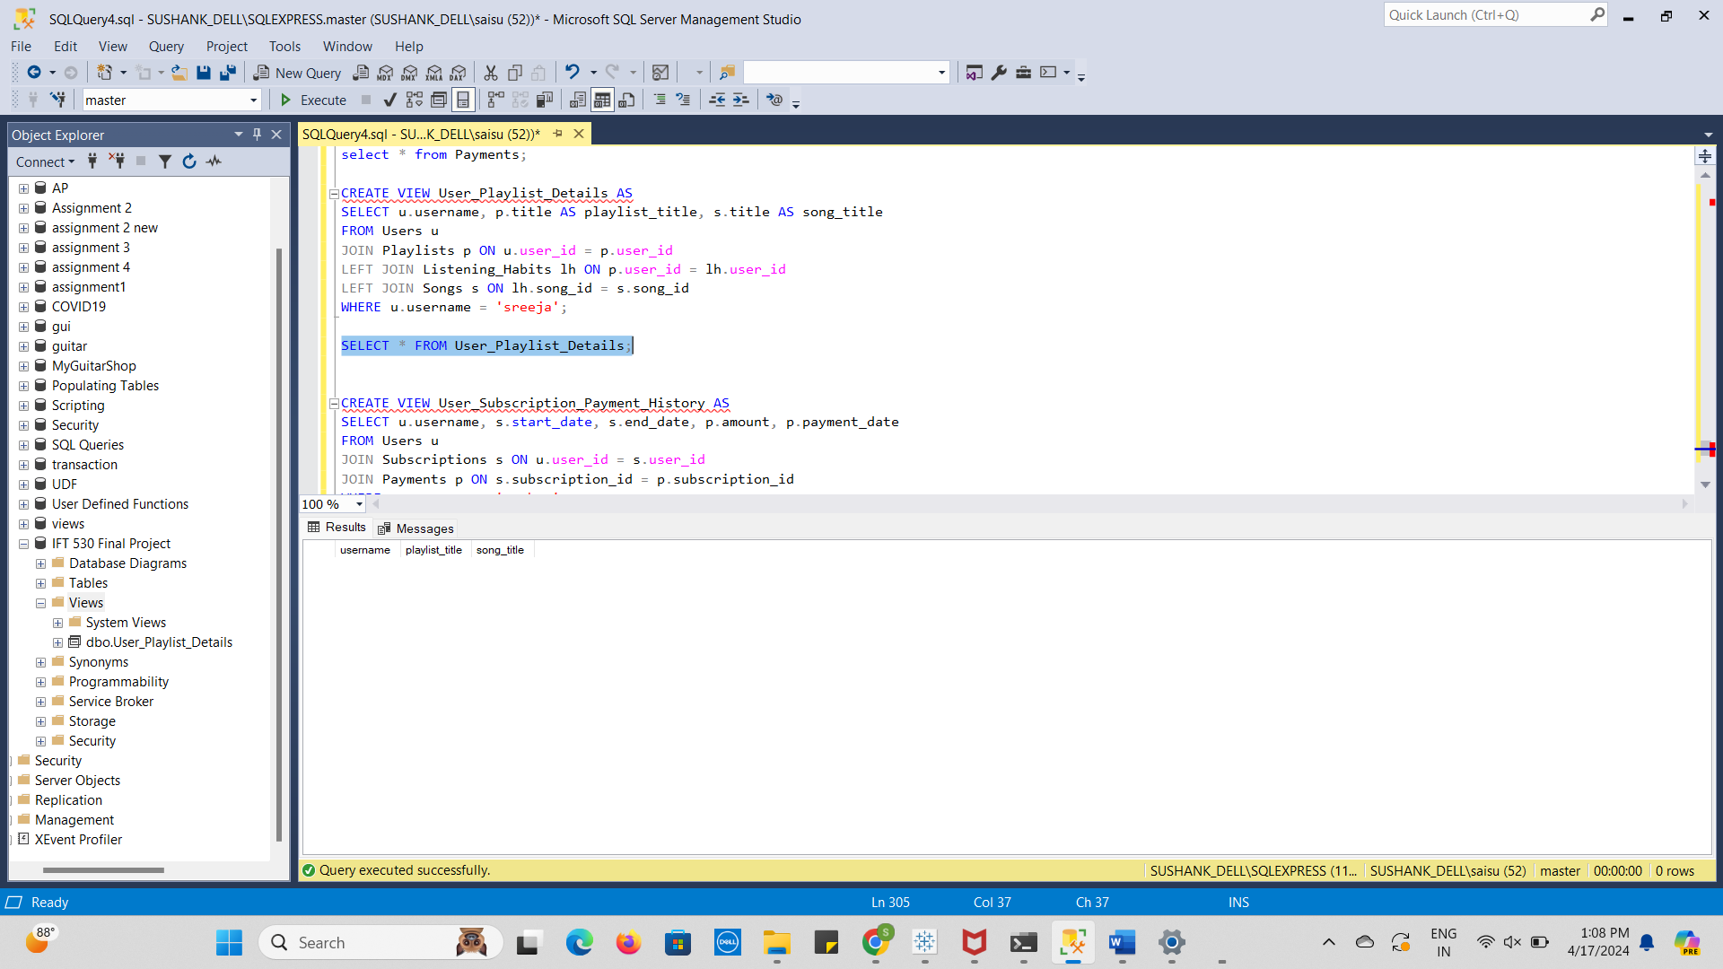

A person may see every playlist made by a certain user, "sreeja," in this view.

It lists the songs that have been added to each playlists along with the playlist titles.

Depending on the songs in their playlists, users may effortlessly control and edit them.

Query 2:

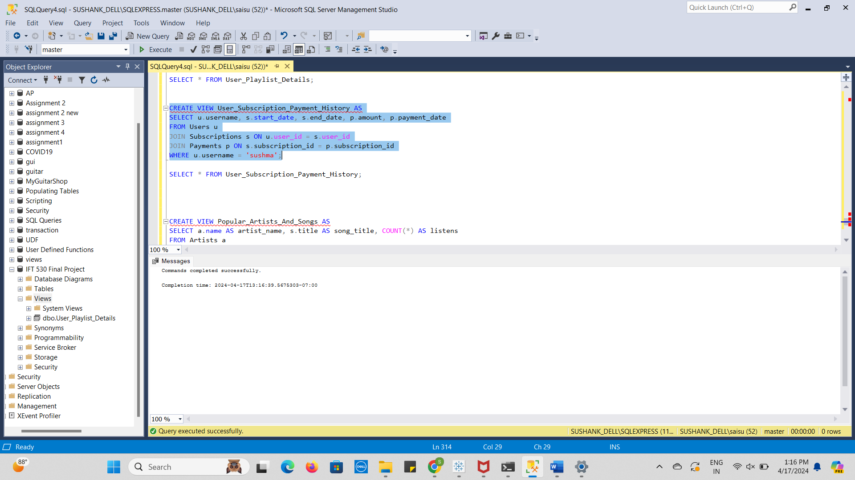

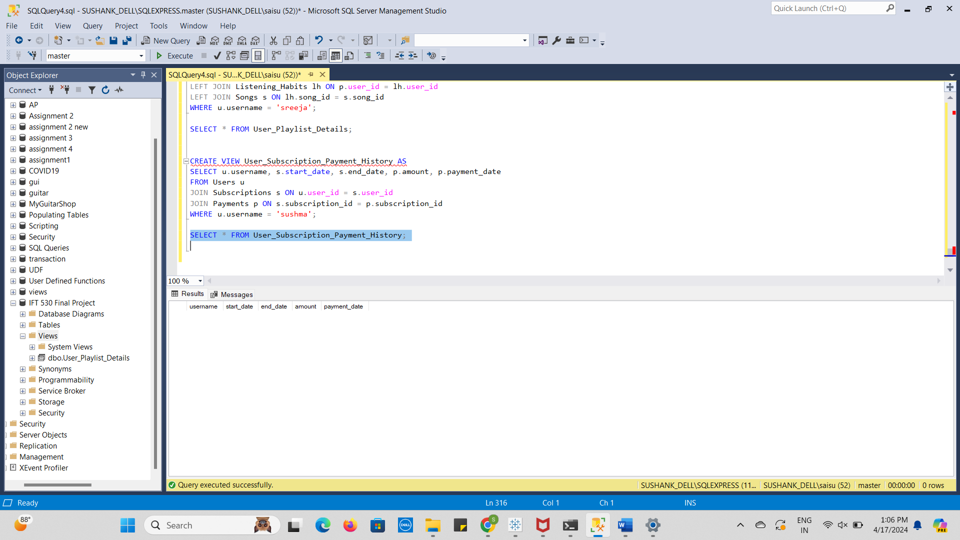

* This view offers 'sushma', the user, a complete history of her purchases and subscriptions.
* It contains information about each subscription, including the start and finish dates, the total amount paid, and the date of each payment.
* It is easy for users to keep track of their past payments and subscription status.

Query 3:

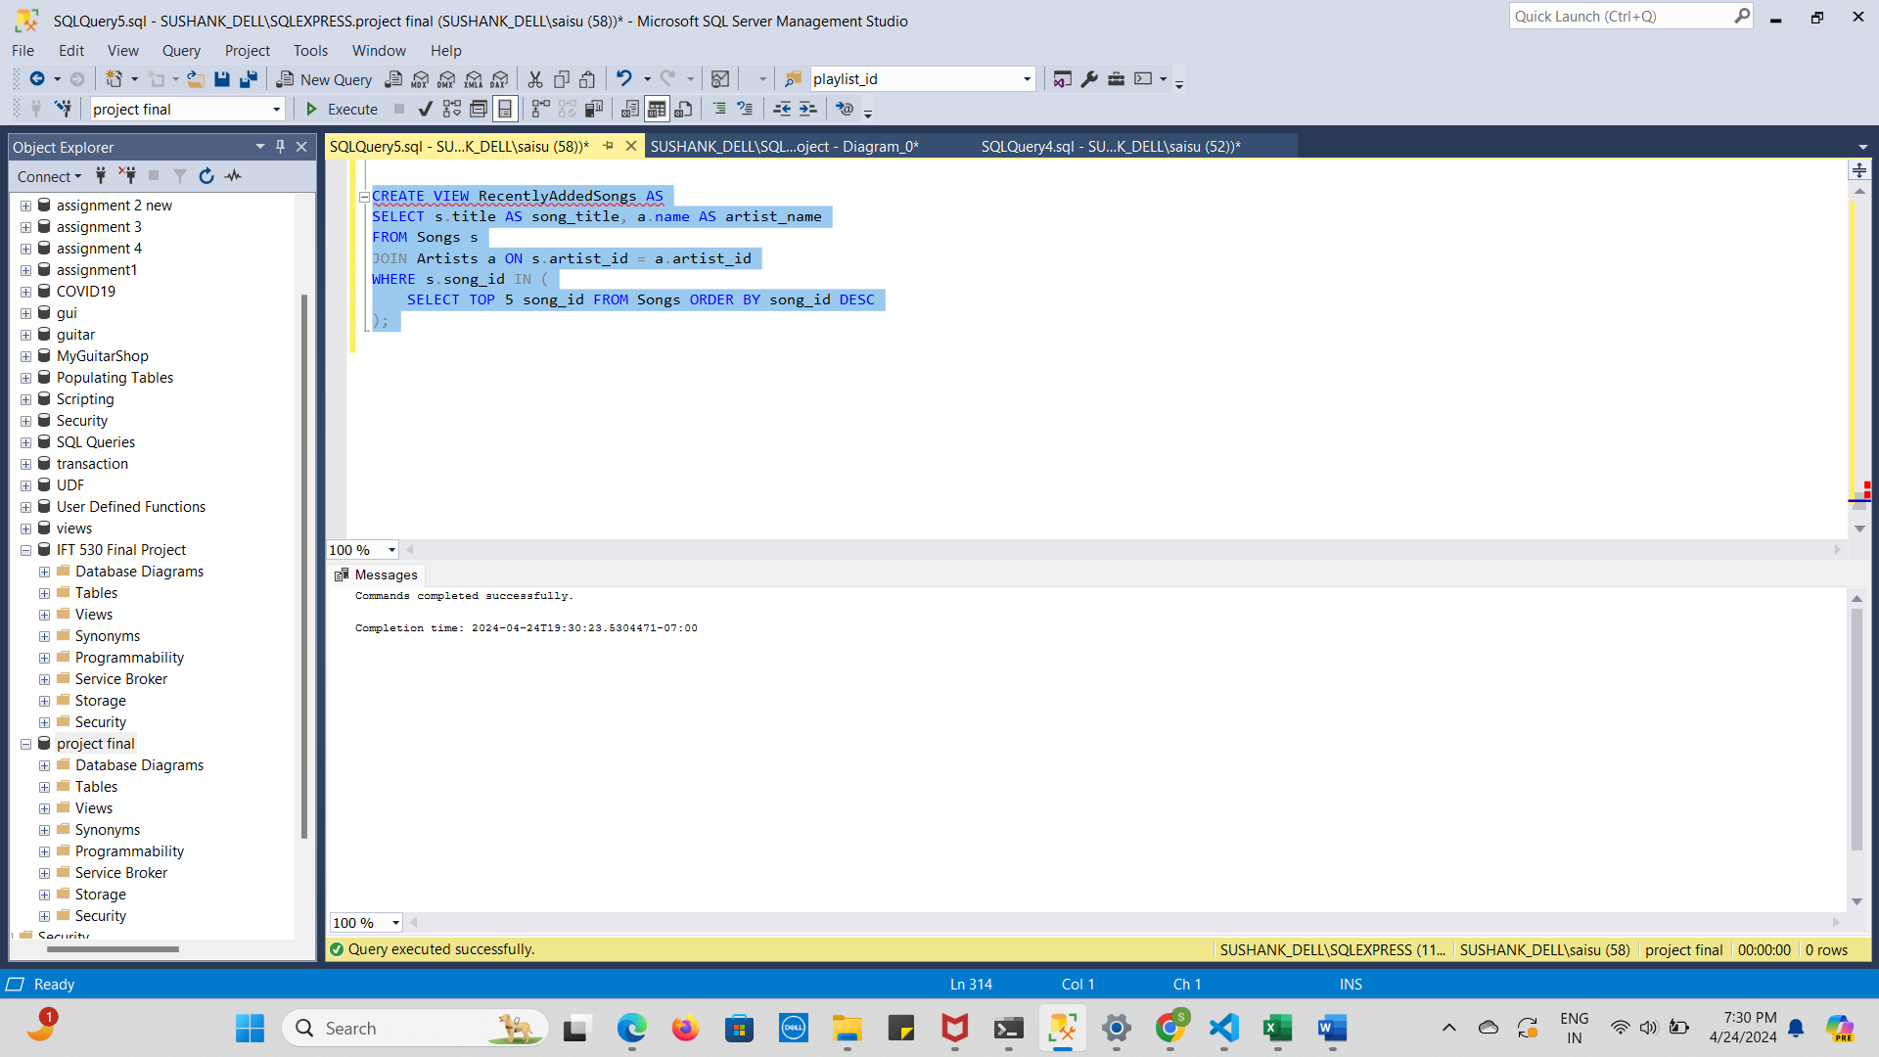

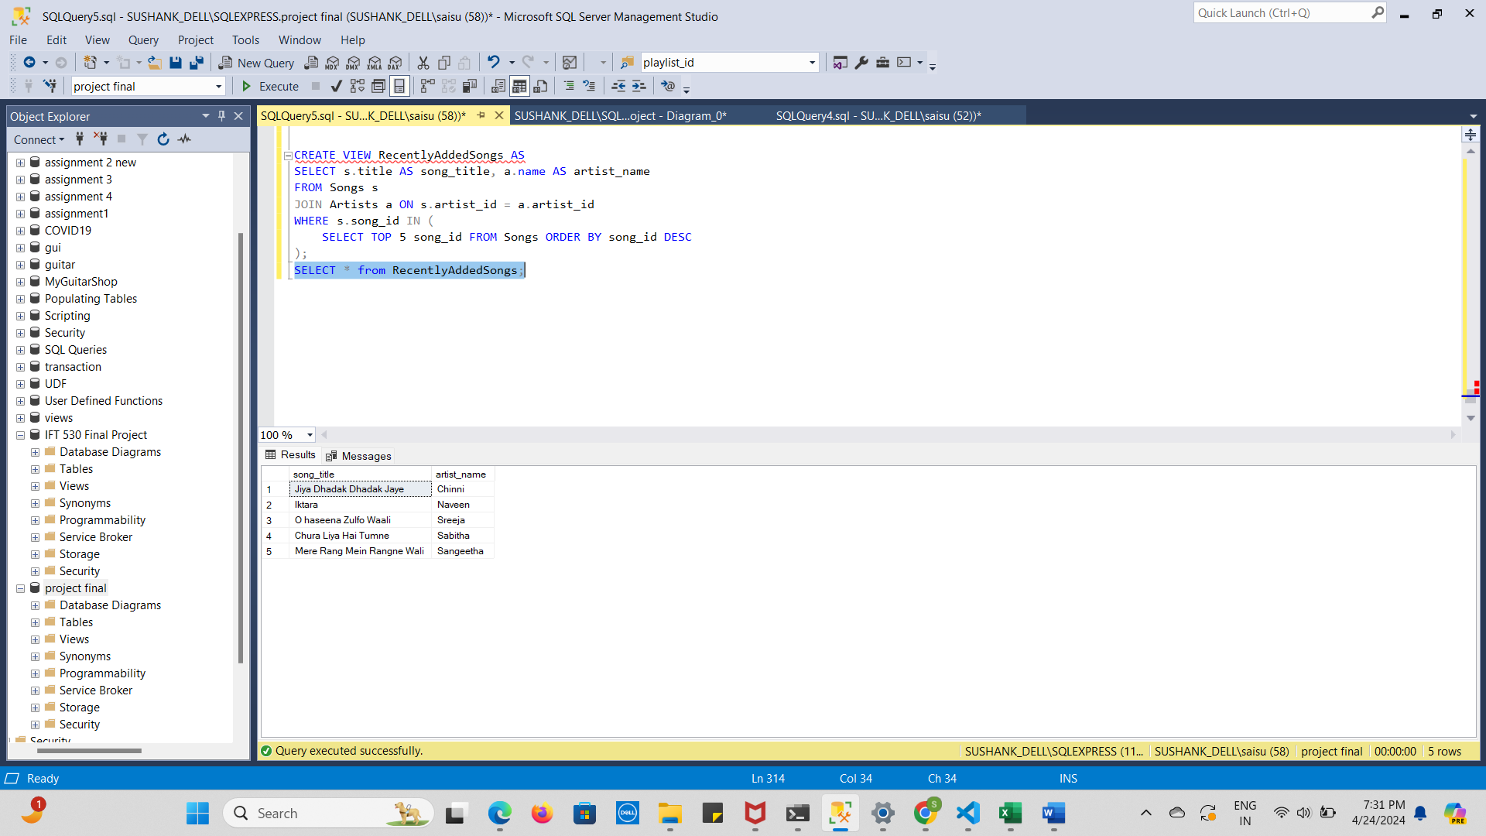

This perspective is advantageous to managers as well as users. To make sure they are aware of how long their premium subscription is valid, users may check its status and see the start and end dates. This view may also be used by administrators to keep an eye on the system's active premium subscriptions.   
  
Individuals as well as administrators may make educated decisions about their audio usage and membership management with the help of such views, which offer insightful information.

Audit Table:

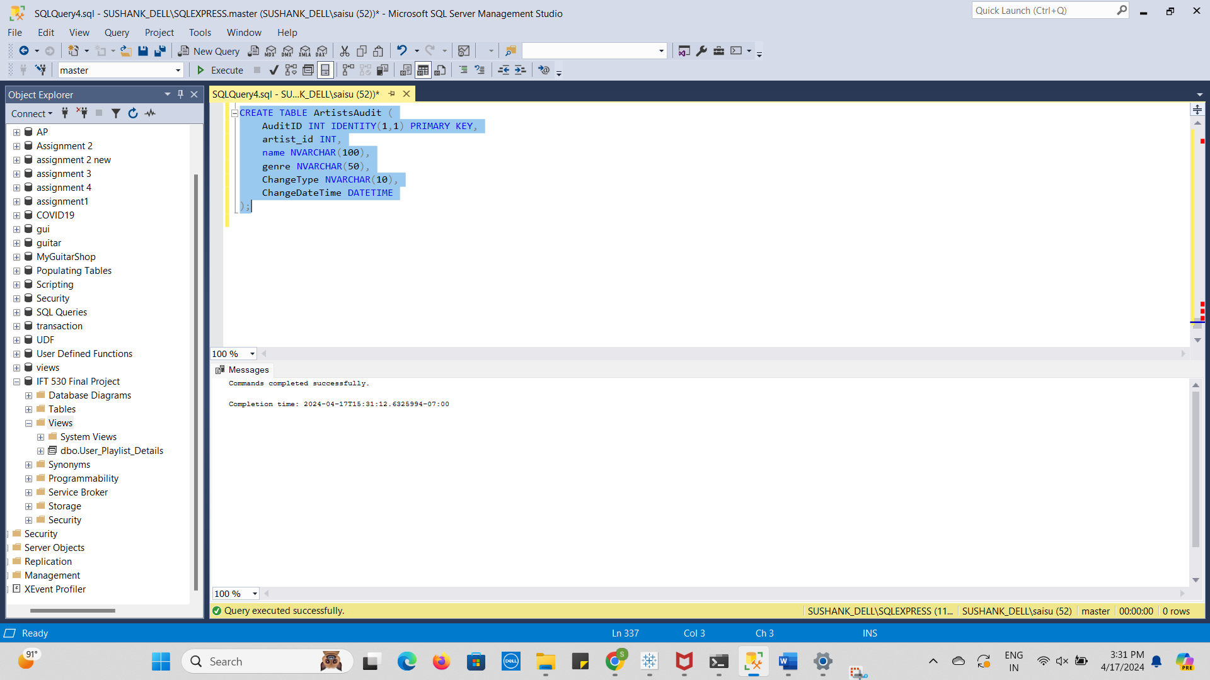

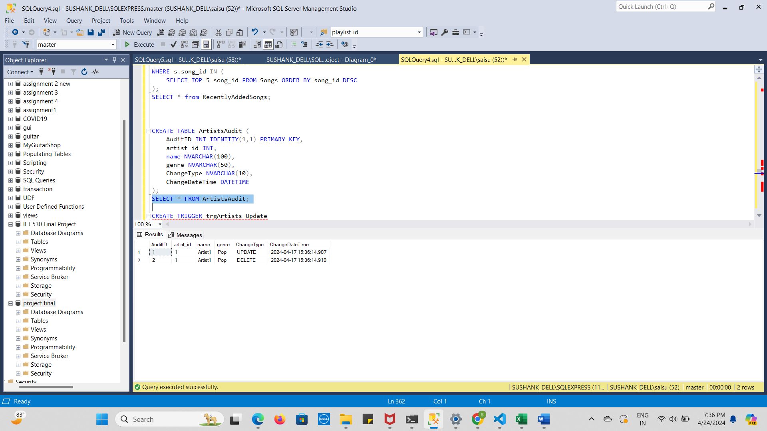

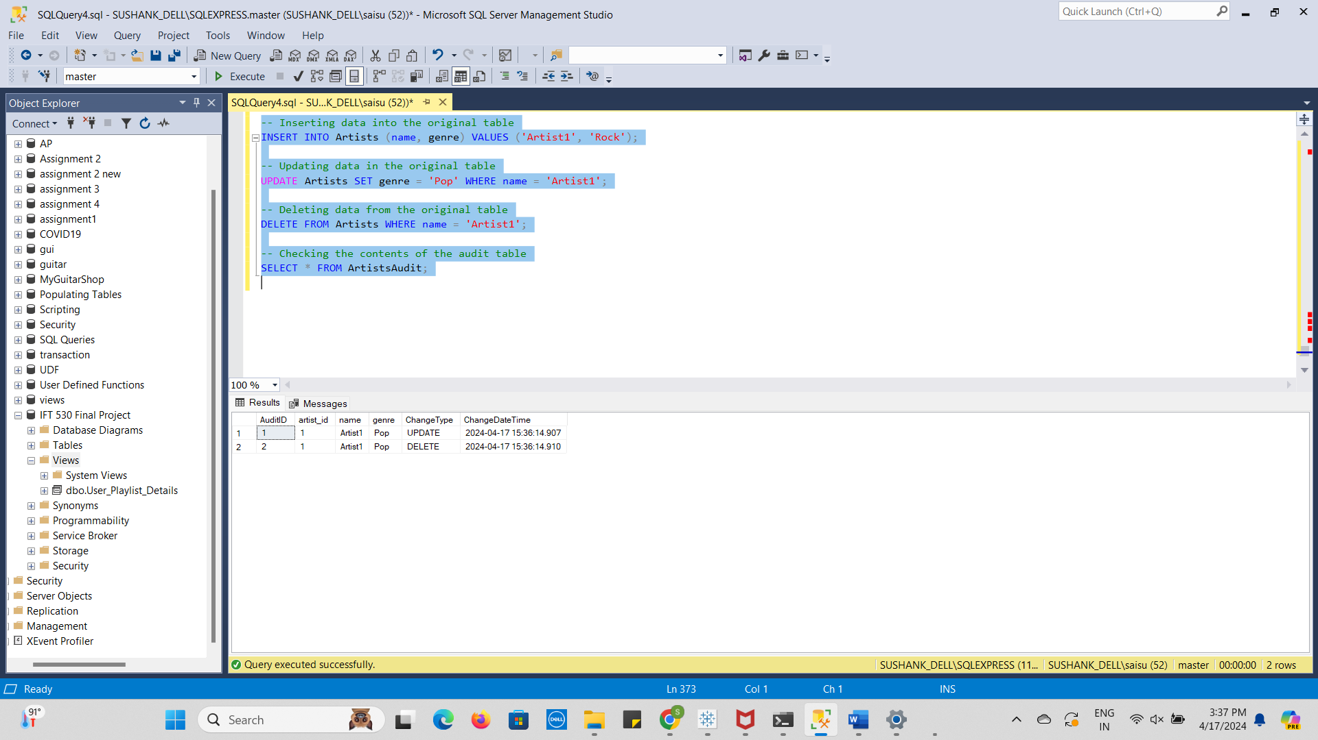

Trigger:

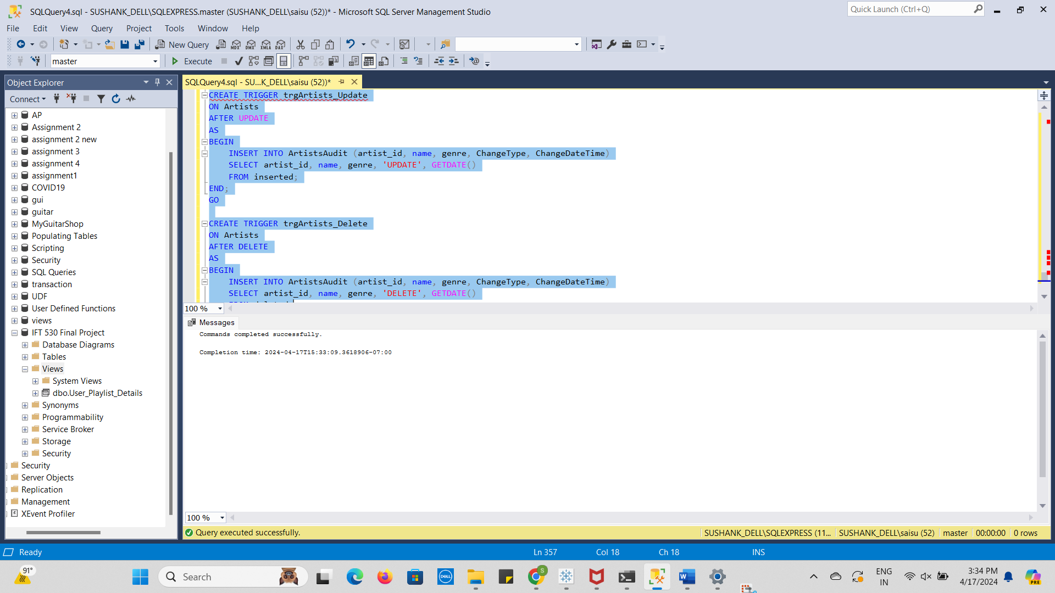

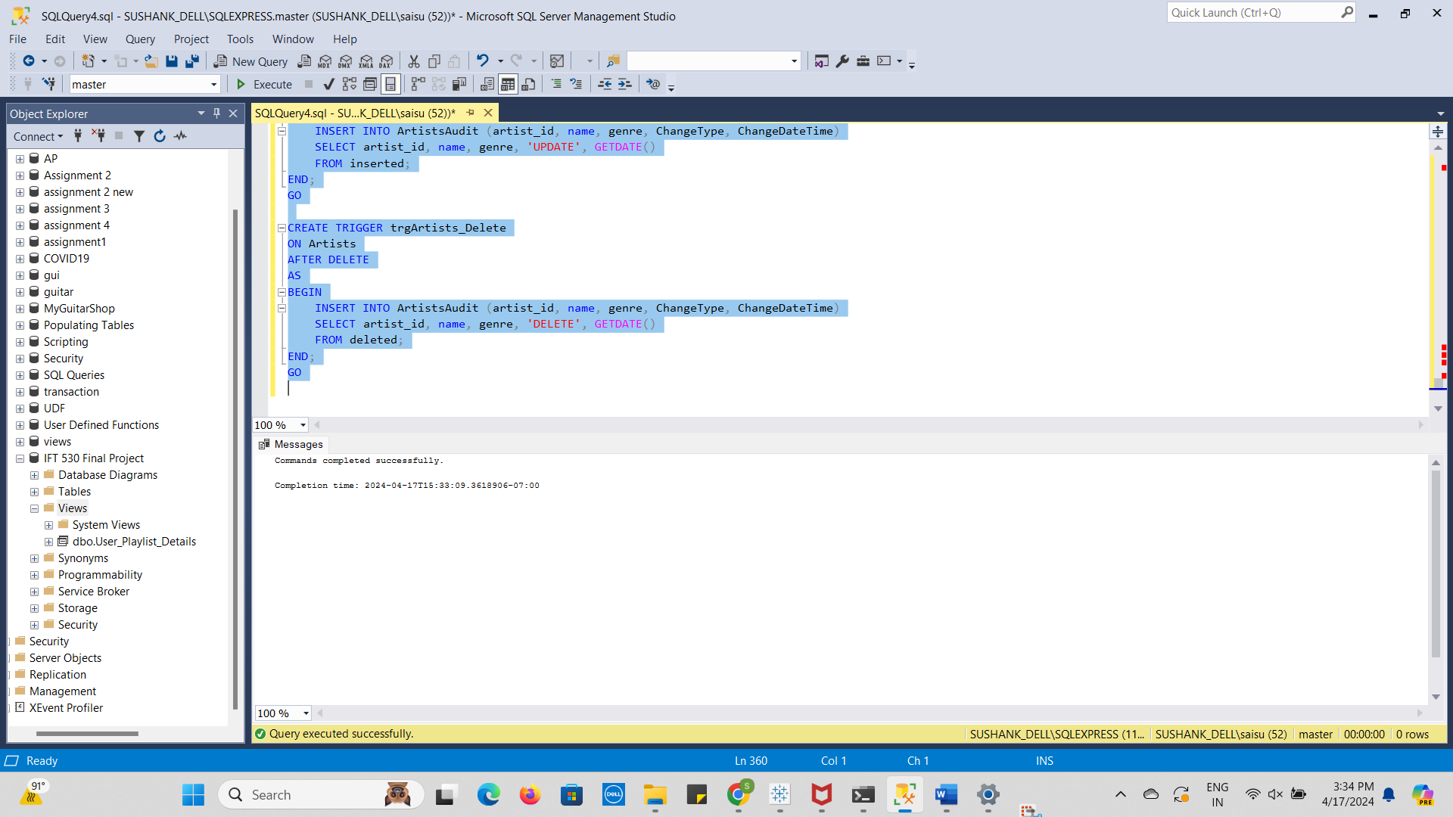

Stored Procedure:

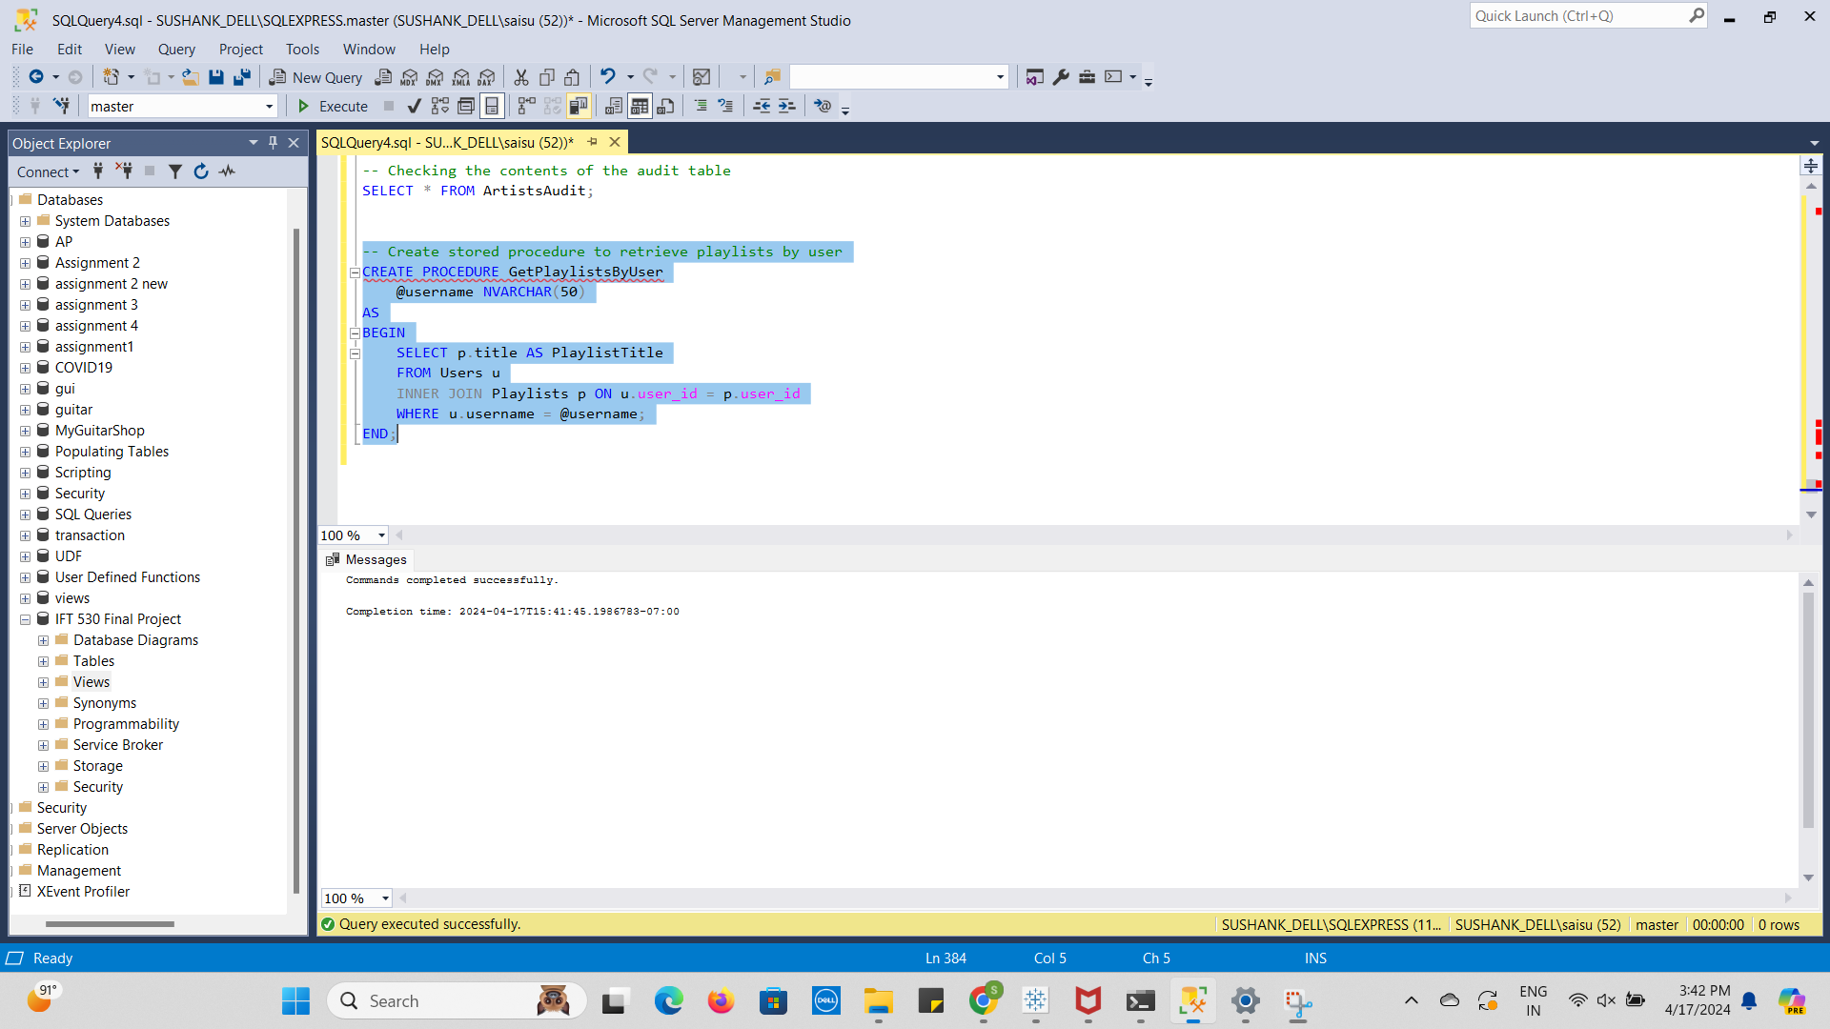

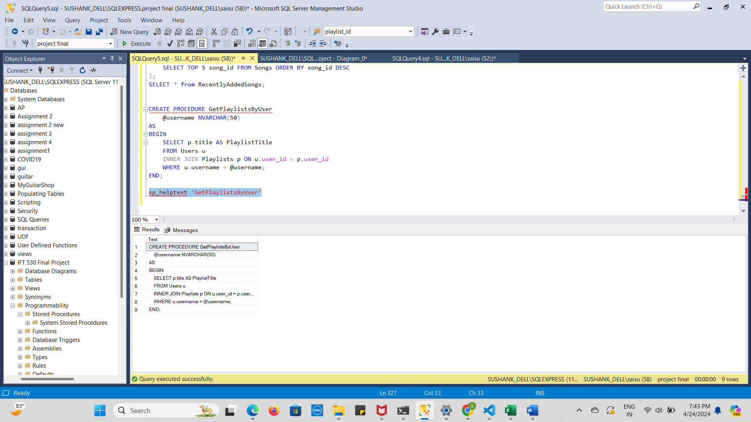

UDF:

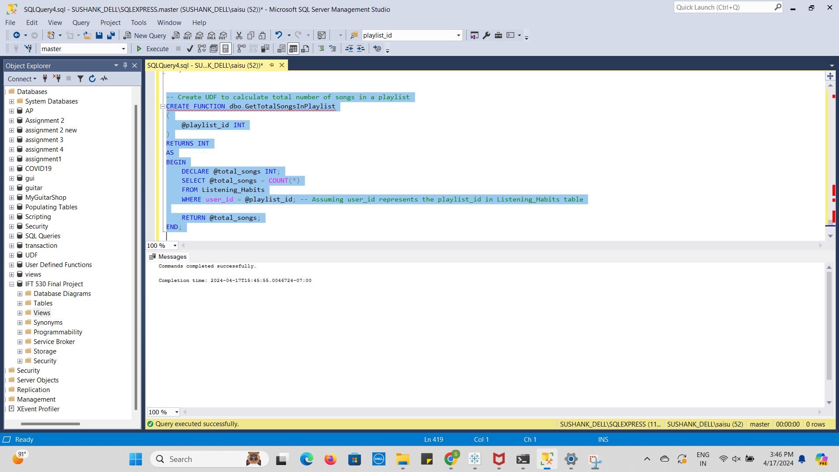

Create and drop scripts:

1. Execute the stored procedure to retrieve playlists by a specific user:

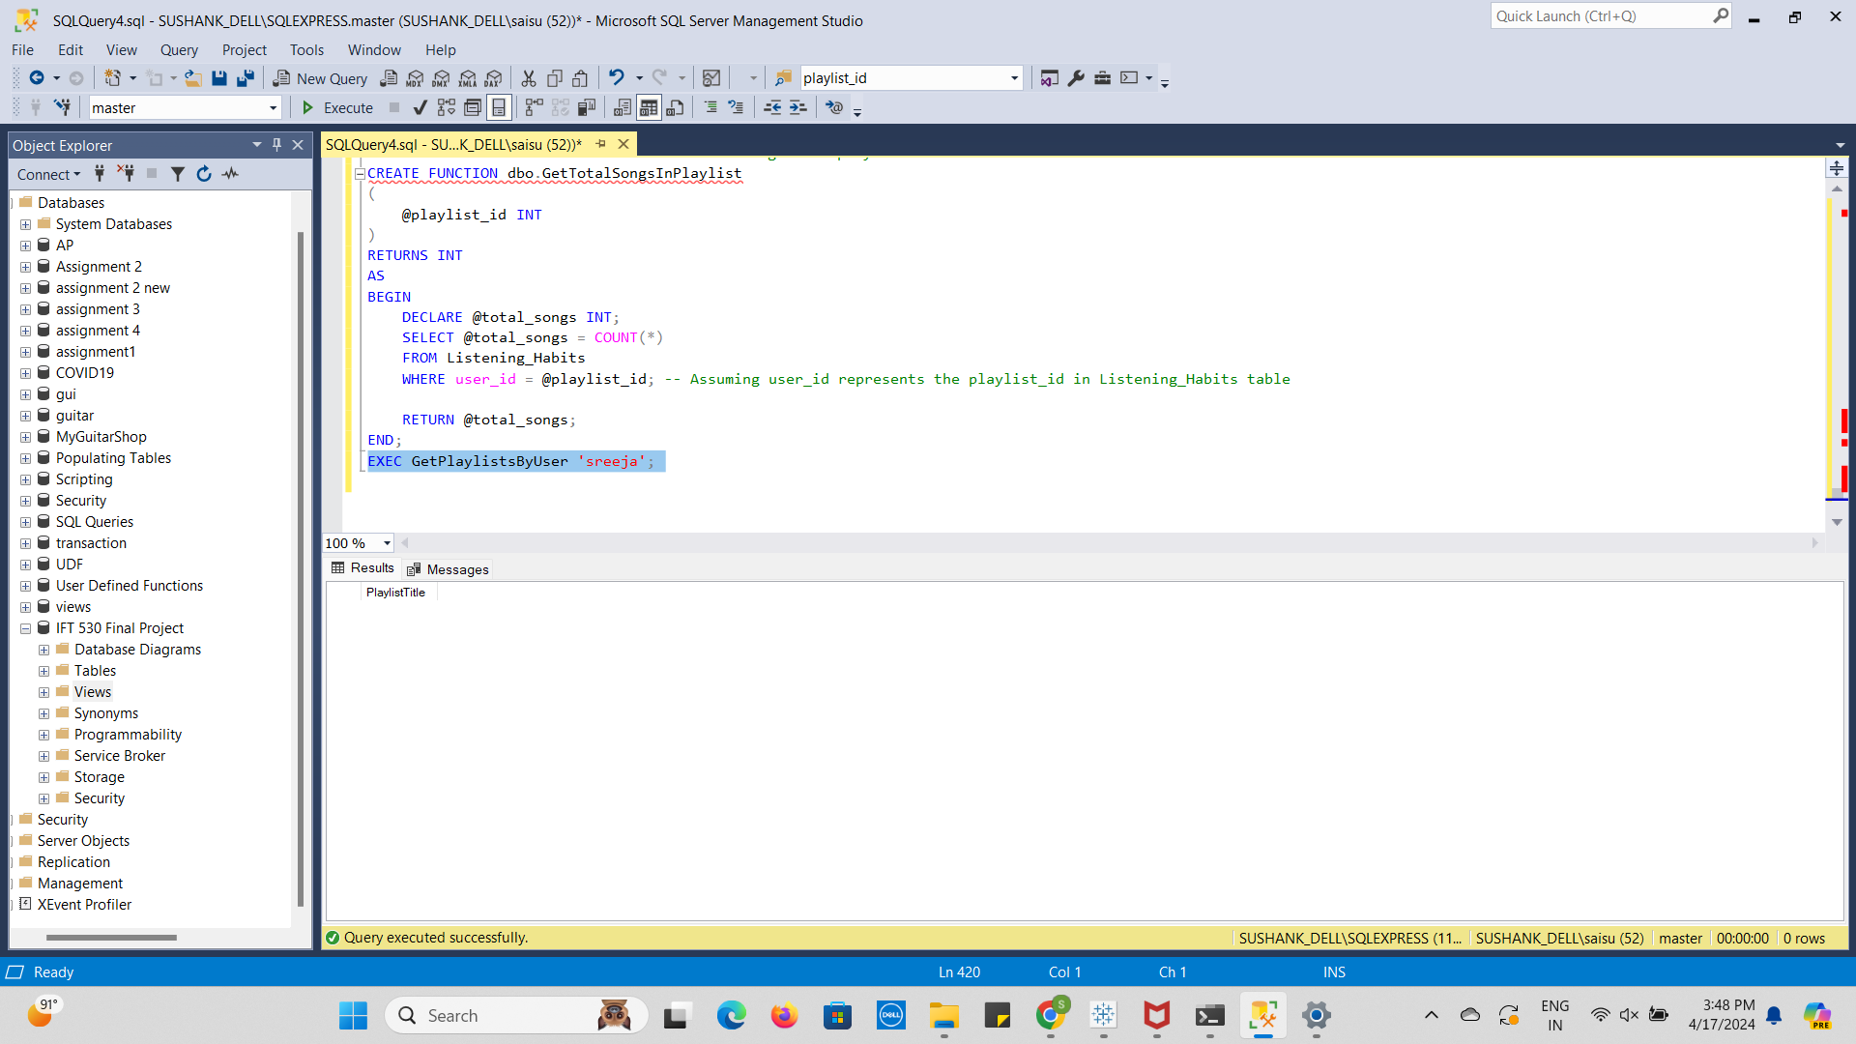

1. Use the UDF to calculate the total number of songs in a playlist:

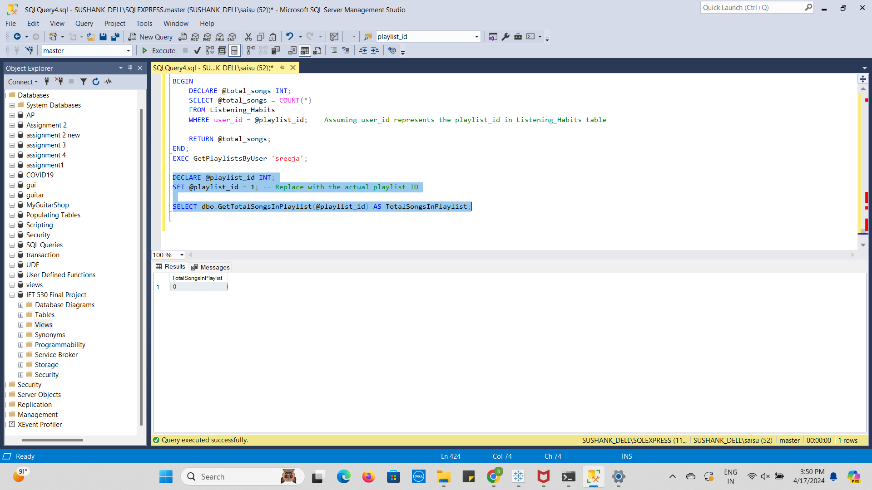

3.Finally, let's include the drop scripts for both the stored procedure and the UDF:

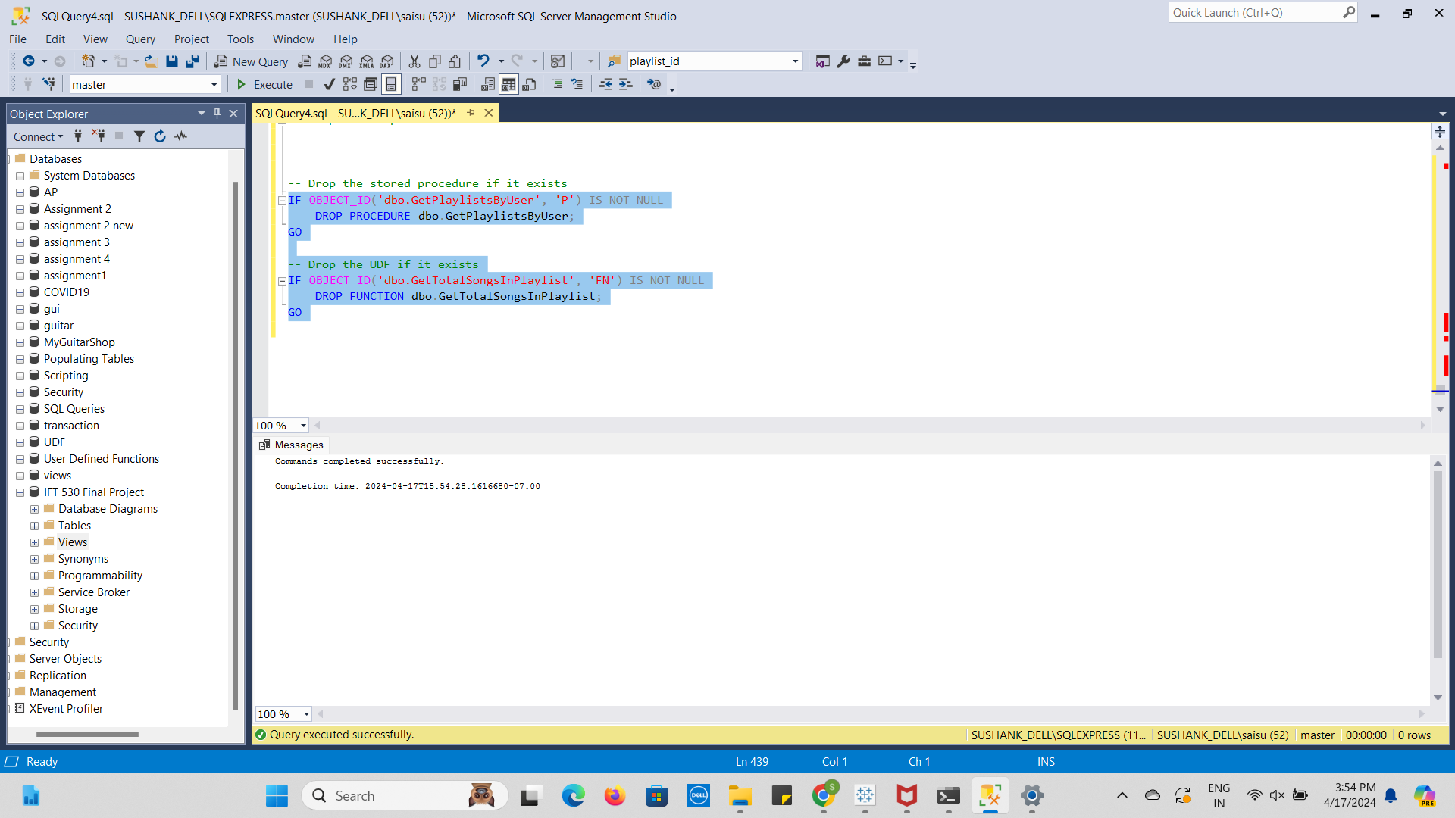

Cursor:

